Appendiceal Carcinoid
Stem: A previously healthy 68-year-old woman is seen in the ED with 18 hours of RLQ abdominal pain and CT findings showing acute appendicitis without perforation, abscess, or phlegmon. You proceeded with laparoscopic appendectomy, patient does well and goes home on POD 1.
Now she is in the clinic for post op, the pathology report had just been signed and released while she was waiting to be roomed. When you walk in to see her, she is obviously distressed and asking you “What is the plan, pathology is showing “tumor”” … She is crying.
Laparoscopic or Open Appendectomy (Describe

You pull the pathology report, and it shows …
- 6mm well circumscribed carcinoid tumor near tip of appendix with no lymphovascular invasion or evidence of perforation ?
  - Reassure, Nothing further
- Path Returns with 14mm well carcinoid tumor at mid appendix with lymphovascular invasion

- PET-Dotatate or Octreotide scan post op, with tumor markers
- Right Colectomy (Describe)
-Open , lap or robotic
- Examine peritoneal surfaces, liver.
- Mobilize the right colon from lateral to medial or medial to lateral
- Enter lesser sac at hepatic flexure.
- separate omentum from transverse colon.
- Divide mesentery.
- Ligate ileocolic vascular pedicle. (Could be done before mobilizing the colon especially with medial to lateral mobilization) -
- Construct ileocolic anastomosis.
- Close mesenteric defect (surgeon preference).

- Path Returns with 34mm well-circumscribed carcinoid tumor at mid appendix without evidence of perforation or lymphovascular invasion.

  - Right colectomy
4. Pathology returns with adenocarcinoma:

  - Stage the patient with CT C/A/P
  - CEA level
  - Colonoscopy if no recent one
  - Right colectomy
- What if, there is a mucinous mass involving the base of the appendix. During mobilization and right colectomy there is spillage of mucin. What next?
Referral for evaluation for HIPEC.

DQ1 Severe colitis & Toxic Megacolon
Stem: 36 yo male presents to the ER with abdominal pain, distention, nausea/emesis, bloody diarrhea, and fever that has been present for 3 days.
Last colonoscopy was 2 years ago with no dysplasia on biopsies and no other surgical history. He notes no recent travel, sick contacts, recent illnesses, or antibiotic usage.
On arrival, he is in significant pain.
PMH: Ulcerative colitis and has not been able to afford his medications due to insurance issues.
Vitals: HR 120s, BP 115/70.
On exam: diffusely tender, distention, voluntary guarding but no rigidity.
Labs: WBC 33, Hgb 9.5, Cr 1.6.
ER obtained a KUB which showed no pneumoperitoneum, dilated loops of small and large bowel.

What is your Differential Diagnosis:
- Ulcerative colitis exacerbation
- Toxic megacolon
- Infectious colitis (shigella, salmonella, E coli)
- C diff colitis
What would you like to do now?
- NPO, resuscitation, NG decompression
- Serial abdominal exams
- CT scan:
  - Diffuse dilation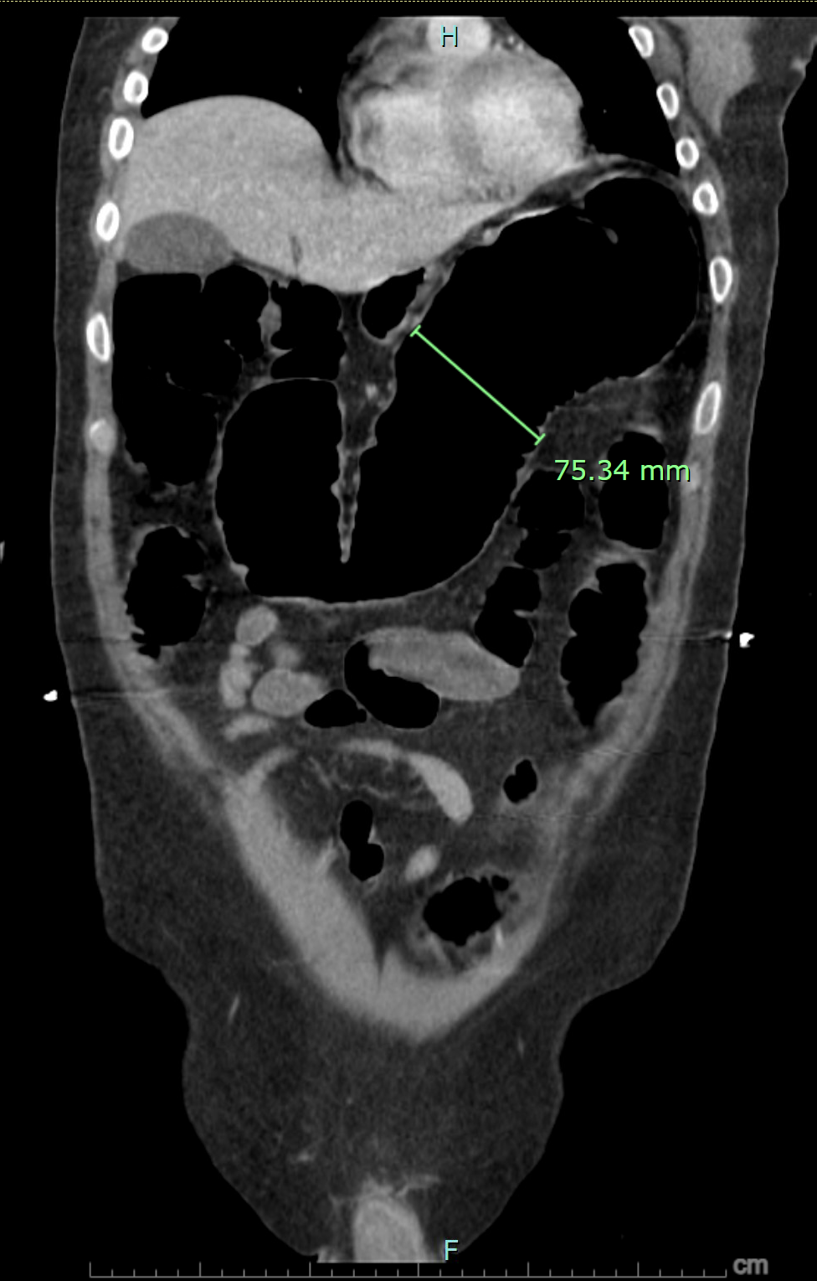

- C diff stool toxin, stool Cx, blood Cx.
- Colonoscopy …. Who will do the colonoscopy (Resident must answer me, if says GI answer is that they refused)
  - Why colonoscopy? Obtain biopsies (Rule out CMV colitis)
  - Describe how you will do it?

- Serial abdominal x-rays
- IV antibiotics,
- GI consultation
- Steroids (100mg hydrocortisone q 6-8 h)
- Add infliximab or cyclosporine if not responding to IV steroids after 48-72 hours.

Scenario Continues: Patient fails to improve after ~72 hours? What would you like to do now?

- Go to OR

- Explain Steps, ( To examiner : Procedure can be either open subtotal colectomy or laparoscopic subtotal colectomy, if lap patient develops stool spillage after handling the colon, difficult to control, need to ex.lap)

- - Ex.lap
- - Subtotal colectomy with end ileostomy, leaving long rectal stump for future procedures.
- - End ileostomy.
- - Rectal stump can be brought out as mucus fistula or drained with rectal drain (Risk of rectal stump dehiscence).

Patient does well afterwards, follows with GI as an outpatient and with you, he is now nutritionally optimized and off all meds, comes back to you desiring reversal, what procedure do you offer him?

Completion proctectomy and IPAA with diverting loop ileostomy followed by Ileostomy reversal in 3 months.

